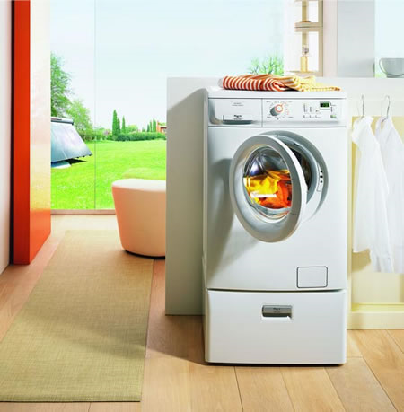

Department of Embedded System
CETPA INFOTECH PVT. LTD

INTRODUCTION

This project is automatic washing machine. The device shows each step to be carried out,on LCD and a beep announces each operation.

This project is designed with most reliable microcontroller based technology to get best reliability and maintenance free life.

Features :
- Time for each operation can easily be changed if required.
- Easy to use for day to day operation.
- Stand alone device – no computer or any other hardware required.
- LCD display
- Needs to be programmed only once.
- Easy to program.

Benefits :
- Accuracy to timings
- No manual intervention
- Saves man power and money
- Easy programming with the help of manual.

CIRCUIT DIAGRAM

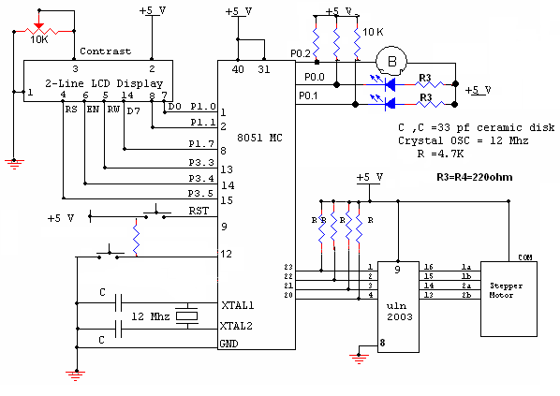

COMPONENTS USED

Sr. no. | Component used | Quantity (no.s)
 | 89c51 microcontroller (base + IC) | 1
 | Diode (4007, .7v) | 4
 | 10k resistance | 6
 | 4.7k resistance | 7
 | 470 ohms resistance | 4
 | Crystal oscillator (12Mhz frequency) | 1
 | buzzer | 1
 | Transformer (220v-909) | 1
 | L.E.D.s | 1
 | Ceramic Capacitor (30pf-33pf) | 2
 | Electrolytic capacitor (100 microfarad,470 microfarad) | 1,1
 | ULN 2003 | 1
 | Voltage regulator (7805)(+5v) | 1
 | 2-Pin connector | 1
 | 5-pin connector | 1
 | 2- pin switches | 1
 | LCD(2*16 Line) | 1
 | Stepper Motor | 1
 | Supply wire | 2 mts

CIRCUIT DESCRIPTION

In this project we have used 8051 microcontroller.20th pin of microcontroller is ground whereas 40th pin is supply. LCD is connected with the port 1 of the MC. Control lines are connected with port 3 of the MC. The contrast of the LCD is controlled by 10k variable resistor and buzzer is connected to port P0.2.

When reset is pressed “WELCOME TO ALL” will be displayed on LCD. Now after 2 sec buzzer will ring displaying “PUT WATER AND DETERGENT” on the LCD and now after dat motor rotate for 6sec.
Then ‘SOAK CLOTH” will be displayed and again motor rotates for 6sec.and after that “RINSE” is displayed on lcd and at last ‘FINISH” is displayed.

PROGRAM:

;program for a stepper having connected at p2(form p2.0
;to p2.3)& to show message on the LCD

data equ p1
busy equ p1.7
rs equ p3.5
rw equ p3.4
en equ p3.3
bzr equ p0.2
ledf equ p0.0
ledb equ p0.1

org 400h

show0: db 'Welcome To All','0'
show1: db 'FILL WATER AND DETERGENT','0'
show2: db 'SOAK CLOTHES','0'
show3: db 'RINSE','0'
show4: db ‘WASH’,'0'

org 0000h
ajmp main

org 0003h
test: mov c,p3.2
jnc halt
setb p0.2
reti
halt:
clr bzr ;till zero blow on the bzr
ajmp test

main:
mov ie,#00h
setb ea
;setb ex0
here:
mov p2,#00h
acall ini
mov dptr,#show0
acall read
clr ledf ;p1.0
acall delay

mov a,#01h
acall command; Now make memory clear cursor home
mov dptr,#show1
acall read
setb ex0 ;#############
mov a,#0c0h
acall command
mov dptr,#show3
acall read
acall delay ;Stopage1 time 3 sec rookee
acall delay
clr bzr
acall delay

mov a,#01h
acall command
mov dptr,#show2
acall read
mov a,#0c0h
acall command
mov dptr,#show4
acall read
setb bzr
acall delay10
acall stepperf

mov a,#01h
acall command
mov dptr,#show1
acall read
mov a,#0c0h
acall command
mov dptr,#show4
acall read
acall delay ;Stopage2 time 3 sec shsar
acall delay
clr bzr
acall delay

mov a,#01h
acall command
mov dptr,#show2 ;display ne
acall read
mov a,#0c0h
acall command
mov dptr,#show5
acall read
setb bzr
acall delay10
acall stepperf

mov a,#01h
acall command
mov dptr,#show1
acall read
mov a,#0c0h
acall command
mov dptr,#show5
acall read
acall delay ;Stopage2 time 3 sec Meerut
acall delay
clr bzr
acall delay

setb ledf ; p1.0 ;off led at p1.0 for forward journey
clr ledb ; p1.1 ; 0n Led for back ward journey

mov a,#01h
acall command
mov dptr,#show2 ;display ne shar
acall read
mov a,#0c0h
acall command
mov dptr,#show4
acall read
setb bzr
acall delay10
acall stepperb

mov a,#01h
acall command
mov dptr,#show1
acall read
mov a,#0c0h
acall command
mov dptr,#show4
acall read
acall delay ;Stopage2 time 3 sec shsar
acall delay
clr bzr
acall delay

mov a,#01h
acall command
mov dptr,#show2 ;display ne roor
acall read
mov a,#0c0h
acall command
mov dptr,#show3
acall read
setb bzr
acall delay10
acall stepperb

mov a,#01h
acall command
mov dptr,#show1
acall read
mov a,#0c0h
acall command
mov dptr,#show3
acall read
setb ledb ;p1.1
ljmp here

;routine for stepper motor
; Delay Routine
;one sec delay
delay:
push acc
push 00h
push 01h
push p0
push p1
mov r0,#0eh
loopr:
mov a,#0ffh
loopb:
mov b,#0ffh
loopa: djnz b,loopa
djnz 0e0h,loopb
djnz r0,loopr
pop p1
pop p0
pop 01h
pop 00h
pop acc
ret

;dlay stepper
delays:
push acc
push 00h
push 01h
push p0
push p1

mov a,#0ffh
loopa1:
mov b,#0fh
loopb1:
djnz b,loopb1
djnz 0e0h,loopa1

pop p1
pop p0

pop 01h
pop 00h
pop acc
ret

delay10:
mov tmod,#01h
mov tcon,#00h
mov tl0,#0f0h
mov th0,#0f8h
setb tr0
no: jnb tf0,no
clr tr0
clr tf0
ret
;=============== Routine to read data from prog mem

read:
nex: clr a
movc a,@a+dptr
cjne a,#'0',aga
sjmp down
aga: acall display
inc dptr
sjmp nex
down:
ret
;================ stepper routine

stepperf:
push acc
push p1
mov a,#88h
mov r1,#04h
loop1:
mov r0,#0e0h
loop: mov p2,a
acall delays
rr a
djnz r0,loop
djnz r1,loop1
pop p1
pop acc
ret

stepperb:
push acc
push p1
mov a,#88h
mov r1,#04h
loop12:
mov r0,#0e0h
loop0: mov p2,a
acall delays
rl a
djnz r0,loop0
djnz r1,loop12

pop p1
pop acc

ret
;*******************************************************
;LCD strobe subroutines
ini:
mov a,#38h
acall command
mov a,#38h
acall command
mov a,#38h
acall command
mov a,#38h
acall command
mov a,#0eh
acall command
mov a,#06h
acall command
mov a,#01h
acall command
mov a,#80h
acall command
ret

command:
acall ready
mov data,a
clr rs
clr rw
setb en
clr en
ret

display:
acall ready
mov data,a
setb rs
clr rw
setb en
clr en
ret

ready:
clr en
mov data,#0ffh
clr rs
setb rw
wait:
clr en
setb en
jb busy,wait
clr en
ret
end

